2. Nutrients and Energy Acquisition *Chapter 47*

______________________________________________________________________________

I. Heterotrophy: A Functional View *(1093-1095)*

A. Nutrient and Energy Needs

1. The metabolism equation

2. Energy for metabolism

3. Bulk nutrients *versus* trace nutrients

B. Steps in Energy and Nutrient Acquisition

1. Food acquisition

2. Mechanical processing

3. Chemical processing

4. Absorption

5. Elimination of Wastes

II. Digestive Systems: A Structural View *(1096-1109)*

A. Digestive Cavities

# B. Digestive Tracts

III. Herbivores *(1110-1114)*

A. Plants as Food

1. Indigestibility of cellulose

2. Low energy and nutrient yield

3. Self‑defense by plants

B. Structures for Mechanical Processing

C. Chemical Processing and Digestive Endosymbionts in Mammals

1. Types of symbionts

2. Ruminants and their cud

3. Small non-ruminant mammals

V. Carnivores *(1110-1114)*

A. Meat as Food

1. High quality

2. Digestibility

B. Structures of Teeth

02-1

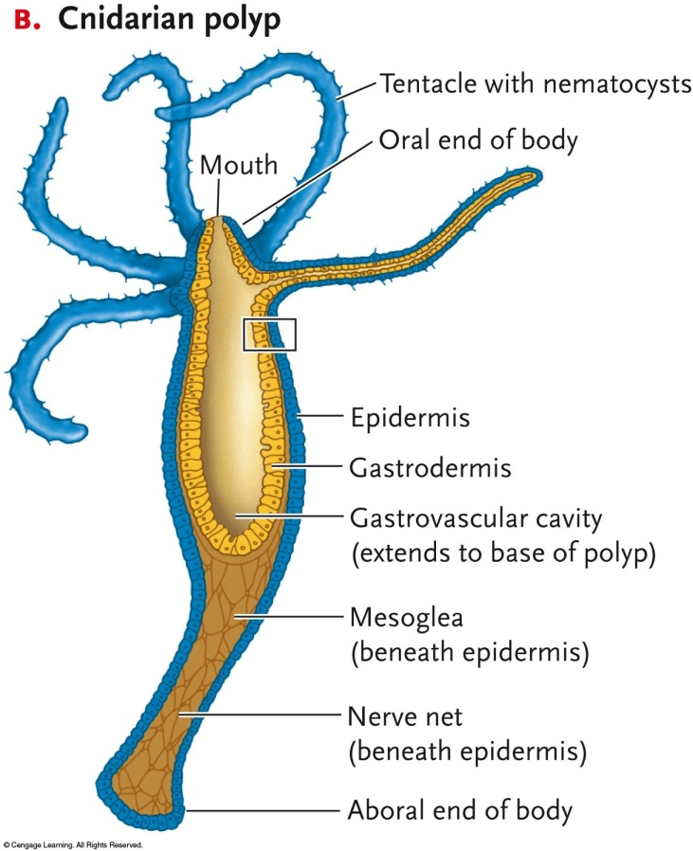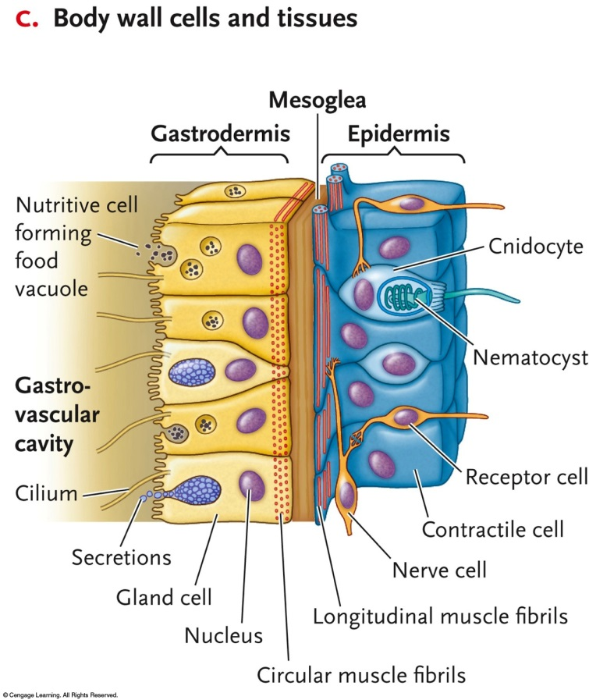

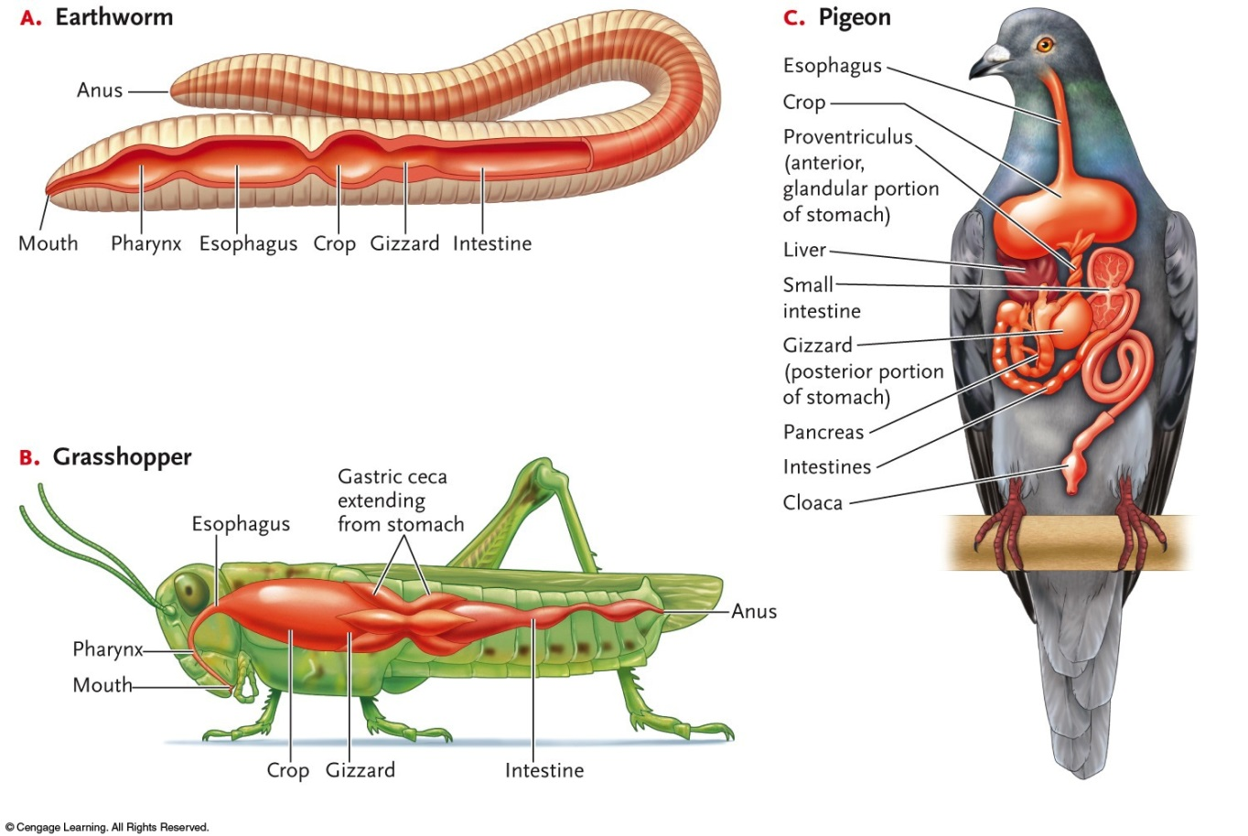

02-2

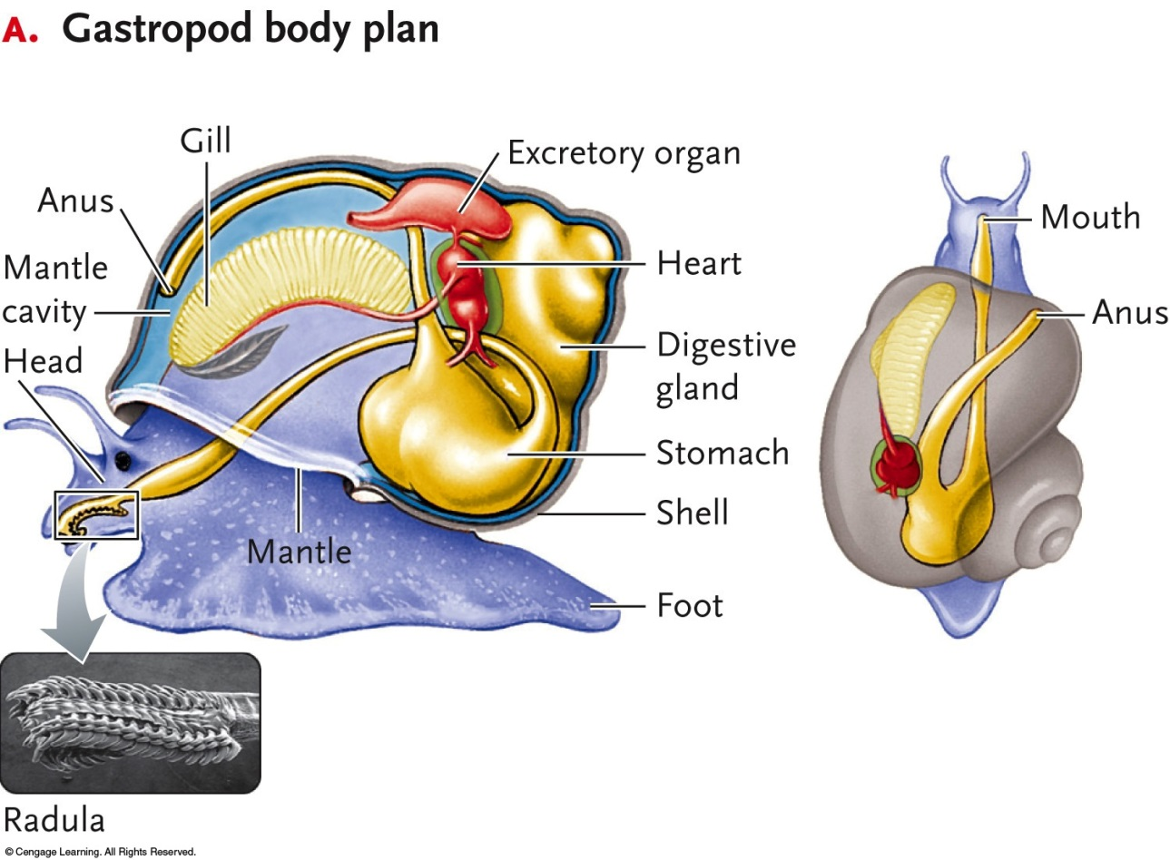

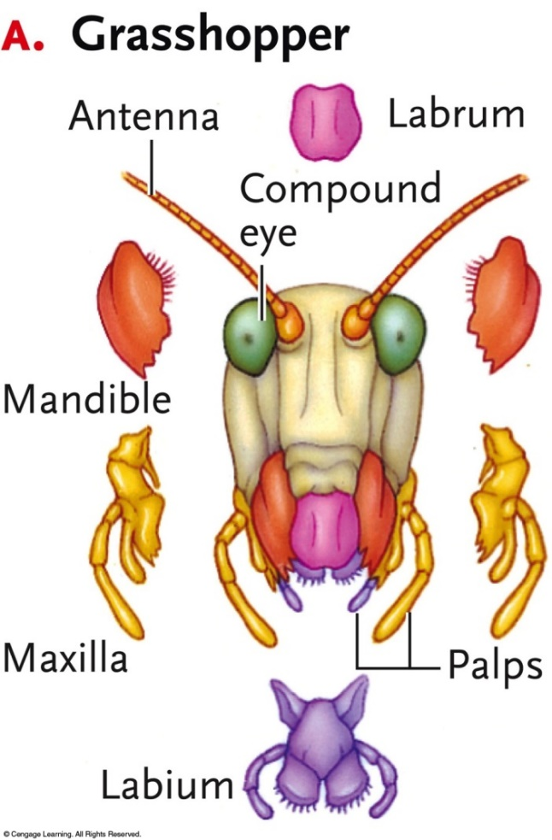

02-3

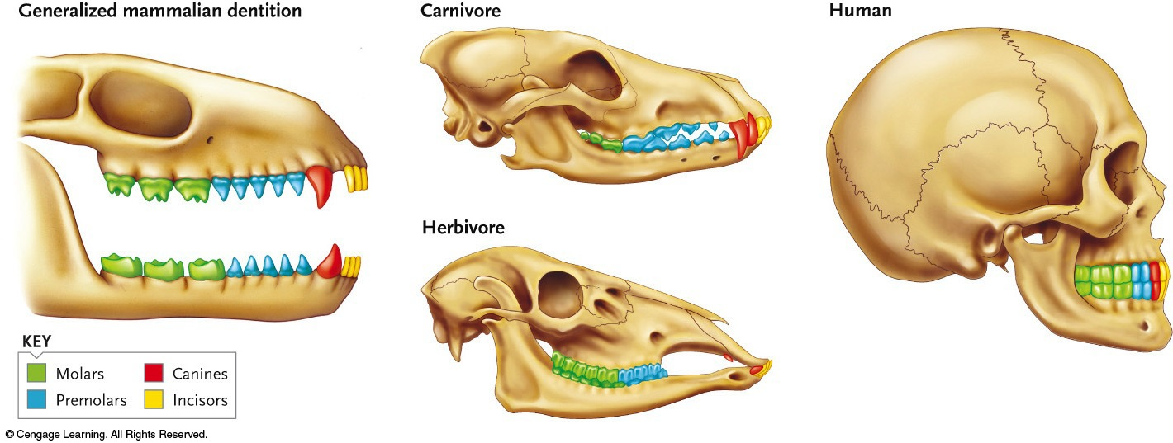

02-4

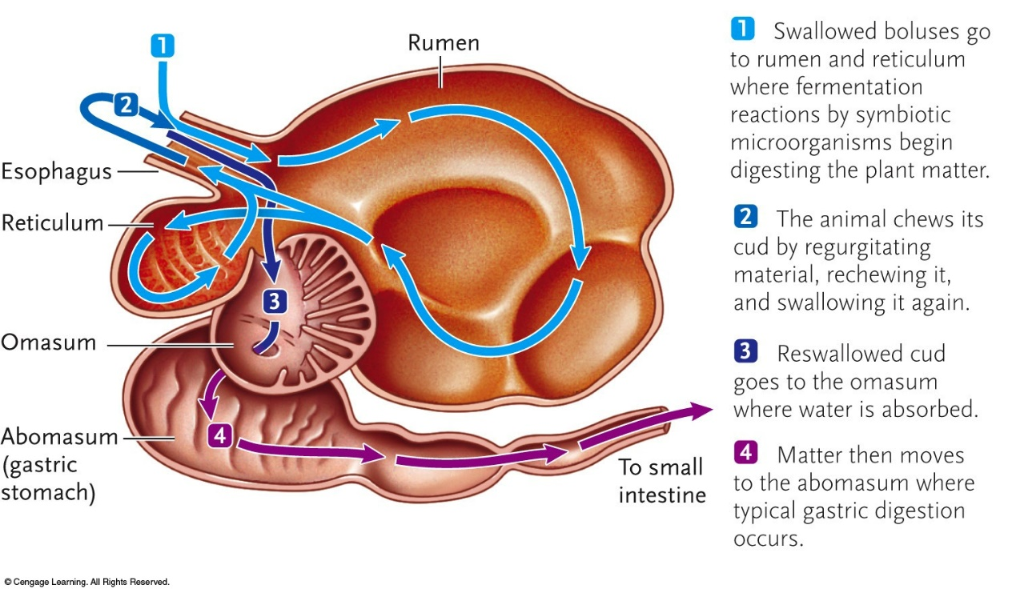

**Carnivore (a dog)**

**Herbivore (a rabbit)**

Esophagus

Stomach

Large intestine

Anus

Cecum

Cecum

Small intestine

Reddogs/Shutterstock.com

Rick Wylie/Shutterstock.com